
Saraswati Academy

Computer science project file
Air x
Airport management system

Name : Manas Kharkwal
Class : 12 ‘A’
Roll no. :
Submitted to: Ms. Pooja Nagarkoti

Group Members:
- Manas Kharkwal
- Shivam Mehta
- Nikhil Sharma

CERTIFICATE
This is to certify that Manas Kharkwal, a student of Class XII, Saraswati Academy, has successfully completed the Project of Computer Science on the topic:

“AirX Airport Management System”
under the guidance and supervision of
Ms. Pooja Nagarkoti, during the academic session 2025–26.
This project is in accordance with the syllabus prescribed by the Central Board of Secondary Education (CBSE) for the partial fulfilment of the requirement of the Computer Science Practical Examination of Class XII.

Signature of External Examiner
Signature of Principal

Signature of Internal Examiner

ACKNOWLEDGEMENT

I would like to express my heartfelt gratitude to my school and our respected Principal, Mrs. Jaya Jantwal for providing me with this wonderful opportunity to carry out our project. Her constant encouragement and the facilities offered by the school have been instrumental in completing this work successfully.
I would also like to extend my sincere thanks to our C.S. teacher, Ms. Pooja Nagarkoti, for her valuable guidance, patient supervision, and continuous support throughout the project. Her insights and suggestions have greatly helped us in understanding the whole concept of Python and MySQL and in preparing this project report.
Lastly, I wish to thank my parents for their constant motivation, moral support, and patience during the course of our work. Their encouragement and faith in me have always been a source of strength and inspiration.

INTRODUCTION
AirX – Airport Management System is a Python and MySQL based application developed to simulate the core functionalities of an airport’s flight and passenger management process. The system is designed to automate essential tasks such as flight scheduling, ticket booking, passenger seat allocation, payment processing, and ticket cancellation. By integrating a database with a user-friendly Python interface, AirX ensures accurate storage, quick retrieval, and secure handling of data.
The project provides separate access for administrators and users. Administrators can manage flight records, while users can view available flights, book tickets for single or multiple passengers, select preferred seats, and choose additional services such as airport lounge access, baggage courier, and in-flight meals. The system also supports flexible payment options, making the booking process efficient and realistic.
The primary objective of this project is to demonstrate the practical application of programming concepts in Python, usage of MySQL and database connectivity. Our project not only reflects real-world airport operations but also highlights the importance of automation in modern transportation systems.

Modules

1. mysql.connector Module:
Provides connectivity between the Python program and the MySQL database.
It is used to store, retrieve, update, and delete flight and ticket data permanently.

a) mysql.connector.connect()
- Establishes connection to the MySQL server
- Returns a connection object

b) connection.cursor()
- Creates a cursor object
- Used to execute SQL queries
cur = con.cursor()

c) cursor.execute()
- Executes SQL commands such as:
  - CREATE
  - INSERT
cur.execute("SELECT * FROM flights")

d) cursor.fetchone()
- Retrieves one row from query result
cur.fetchone()

e) cursor.fetchall()
- Retrieves all rows from query result
cur.fetchall()

f) connection.commit()
- Saves database changes permanently
con.commit()

g) connection.rollback()
- Cancels database changes on error
con.rollback()

h) cursor.close()
- Closes cursor to free resources

i) connection.close()
- Safely closes database connection

2. datetime Module:
Handles date and time operations.

a) datetime.date.today()
- Fetches current system date
today = datetime.date.today()

b) datetime.datetime.now()
- Fetches current date and time
booking_time = datetime.datetime.now()

c) datetime.datetime.strptime()
- Validates date format
datetime.datetime.strptime(date, "%Y-%m-%d")

3. random Module:
Generates random values.
Used to ensure unique ticket numbers.

a) random.randint(a, b)
- Generates random integer between a and b
random.randint(100000, 999999)

4. sys Module:
Provides system-level functions.
Used to terminate the program safely if a critical error occurs.

a) sys.exit()
- Immediately stops program execution
sys.exit(1)

Functions
Function | Purpose
print() | Print output
input() | User input
len() | Checking length
int() | Convert to integer
float() | Convert to float
str() | Convert to string
range() | for loop
set() | Store unique seat numbers
map() | Convert input values
round() | Cost / refund calculation
upper() | Seat number conversion
lower() | Normalize input
isdigit() | To check if input is digit

Mysql querries
1. DATA DEFINITION LANGUAGE (DDL):

1.1 CREATE DATABASE
CREATE DATABASE IF NOT EXISTS airport_system;
Creates a database to store flight and ticket data.

1.2 CREATE TABLE
CREATE TABLE flights (...);
CREATE TABLE tickets (...);
Defines the structure of tables.

1.3 IF NOT EXISTS
CREATE TABLE IF NOT EXISTS flights;
Preventing error if database or table already exists.

2. DATA MANIPULATION LANGUAGE (DML) :

2.1 INSERT INTO
INSERT INTO flights VALUES (...);
INSERT INTO tickets VALUES (...);
Adds new records (flights or tickets) to tables.

2.2 SELECT
SELECT * FROM flights;
SELECT seat_no FROM tickets;
Retrieves data from database tables.

2.3 DELETE
DELETE FROM flights WHERE flight_no = ...;
DELETE FROM tickets WHERE ticket_no = ...;
Removes records from tables.

3️. CLAUSES:

3.1 FROM
SELECT * FROM flights;
Specifies the table from which data is retrieved.

3.2 WHERE
WHERE flight_no =...
WHERE date < CURRENT_DATE;
Applies conditions to filter records.

4️. CONSTRAINTS:

4.1 PRIMARY KEY
flight_no PRIMARY KEY
ticket_no PRIMARY KEY
Ensures uniqueness of records.

4.2 FOREIGN KEY
FOREIGN KEY (flight_no) REFERENCES flights(flight_no)
Maintains referential integrity between tables.

5️. PLACEHOLDER:

5.1 %s
WHERE flight_no = %s
Safely injects Python variables into SQL queries.
Prevents SQL injection.

* Operators : =,>,<,and.

Frontend
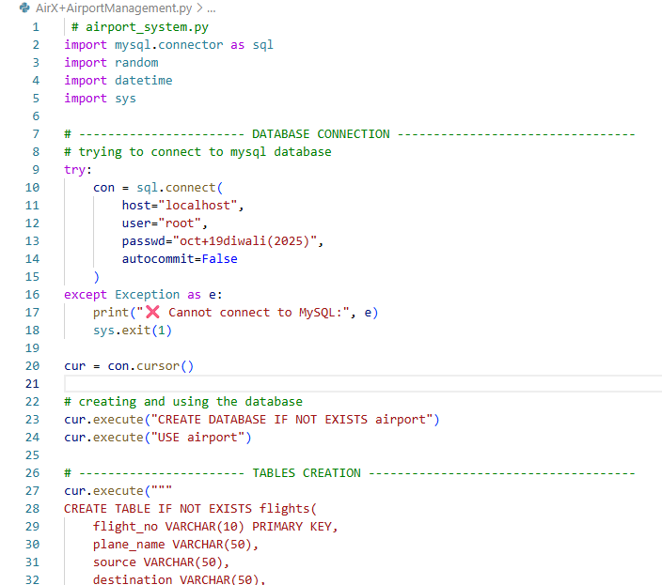

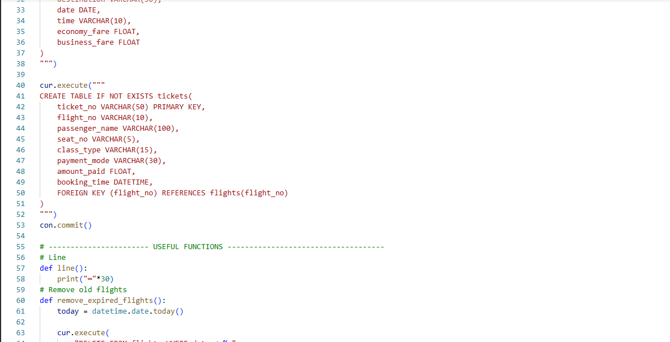

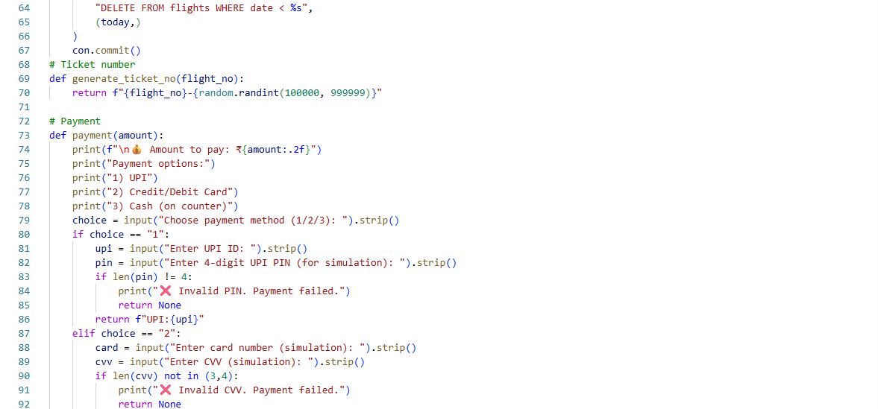

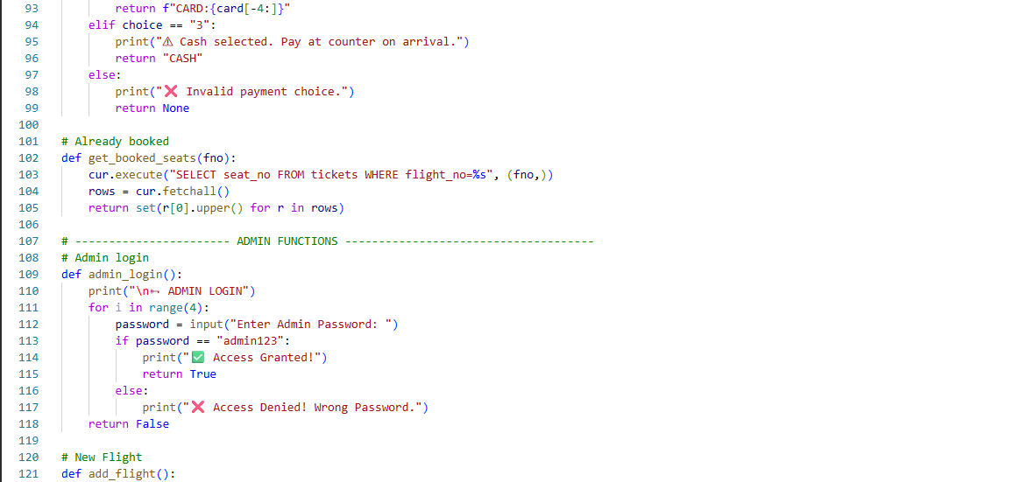

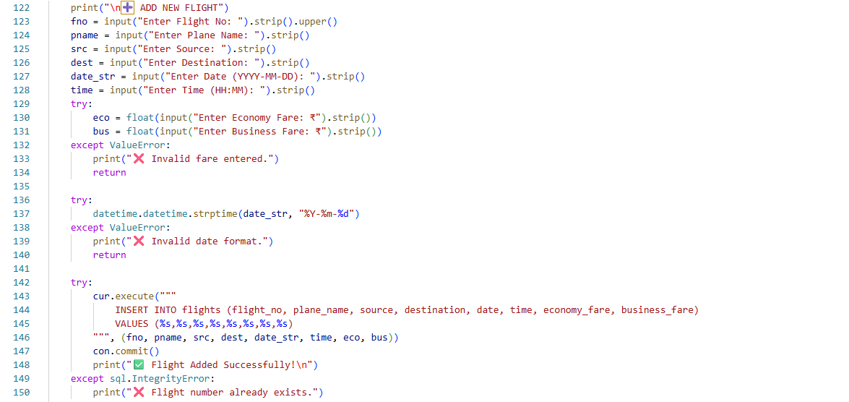

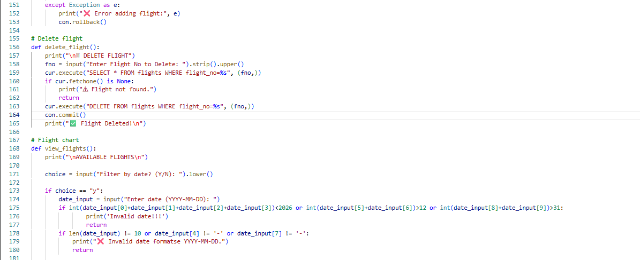

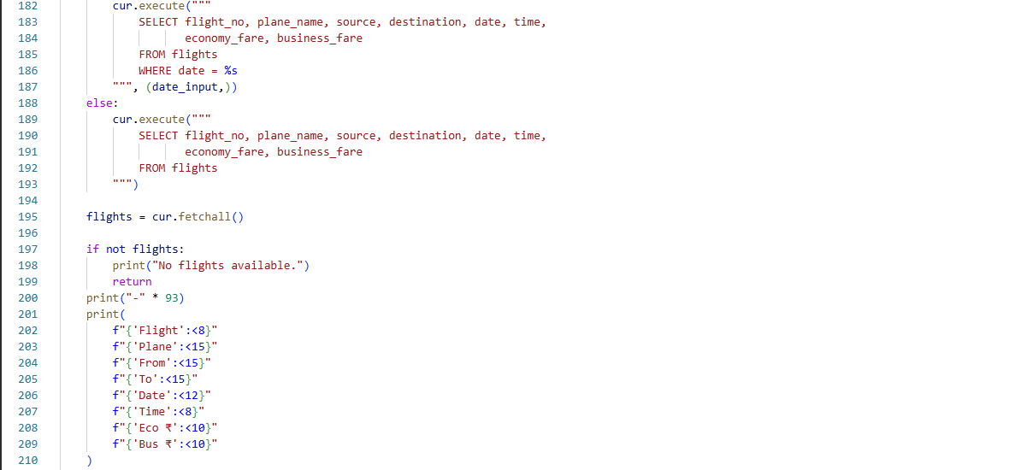

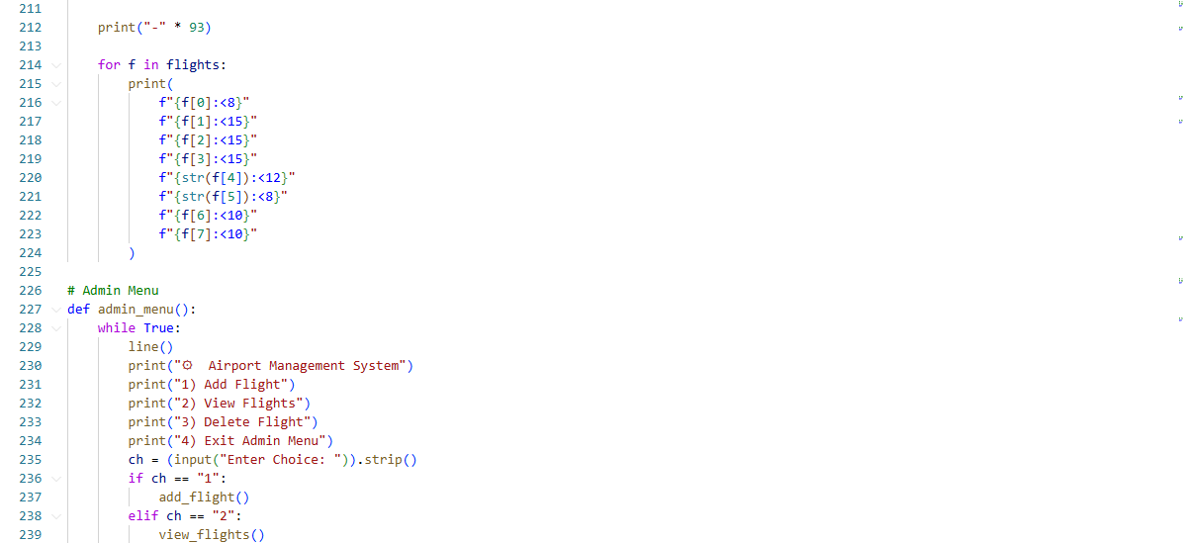

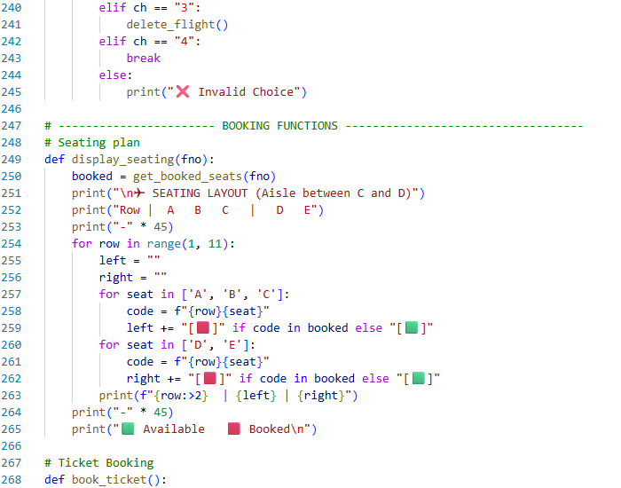

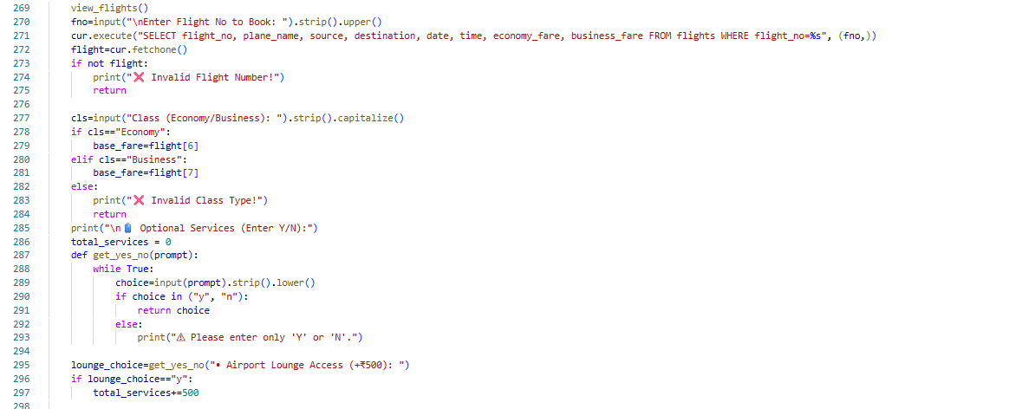

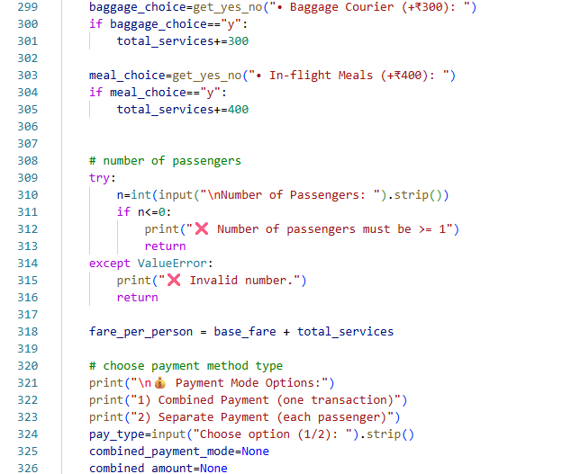

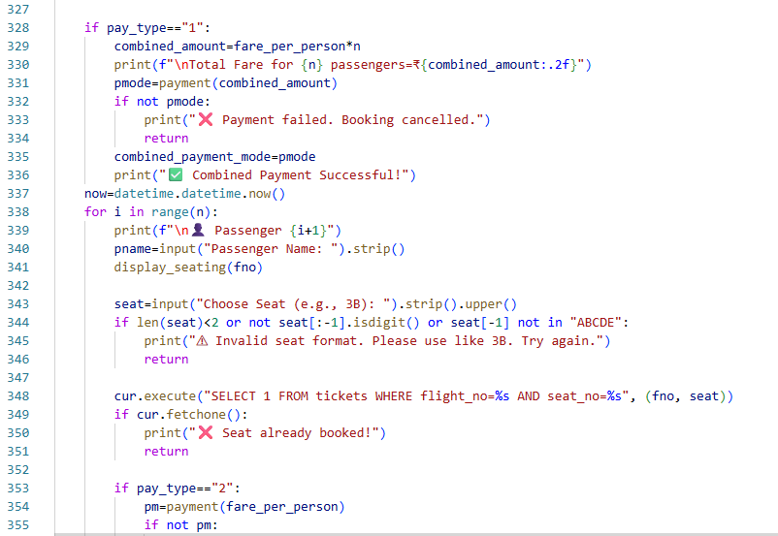

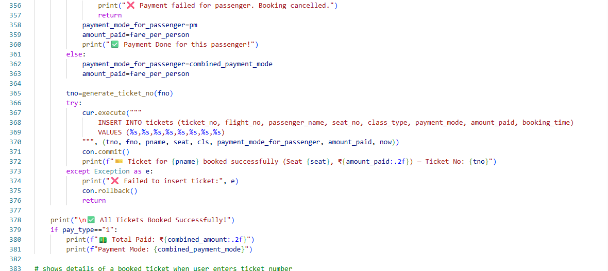

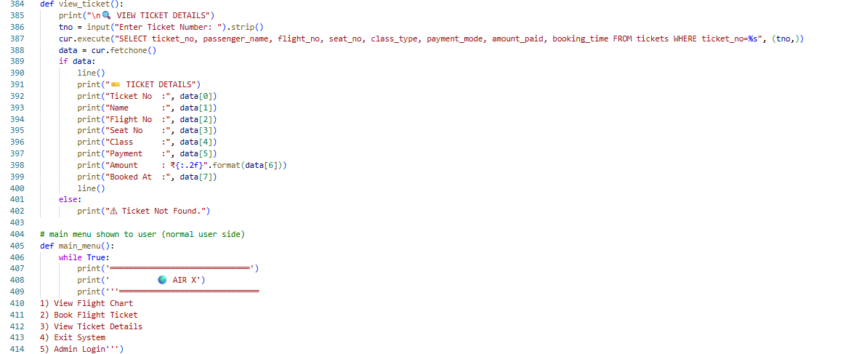

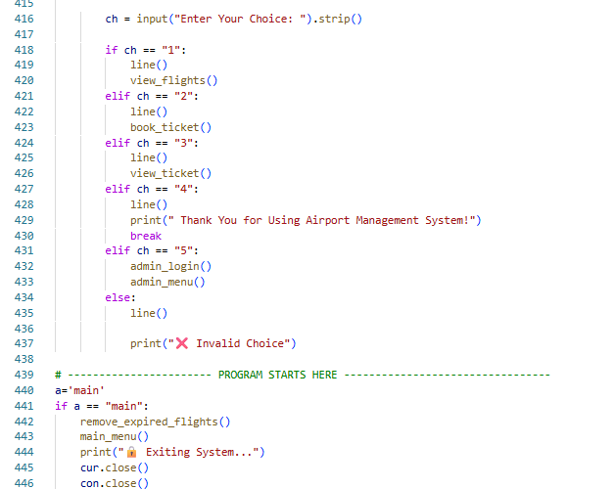

Database
Mysql tables

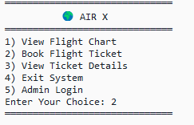
Output

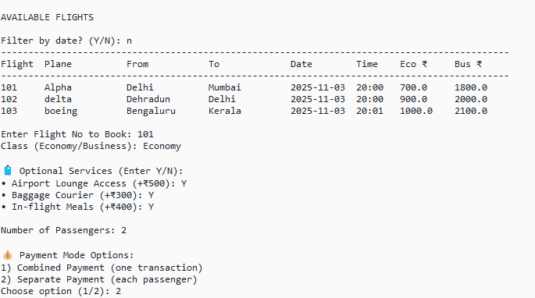

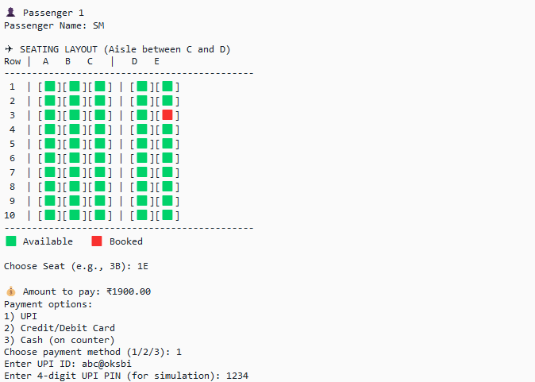

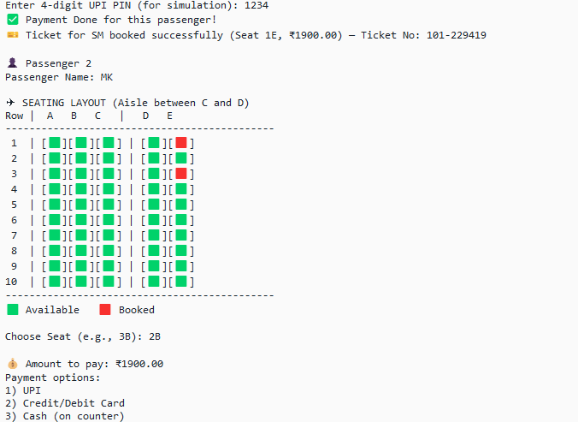

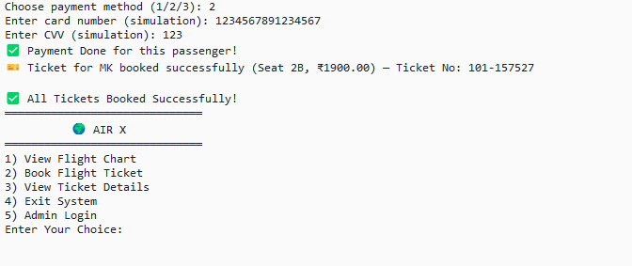

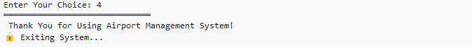

Flowchart
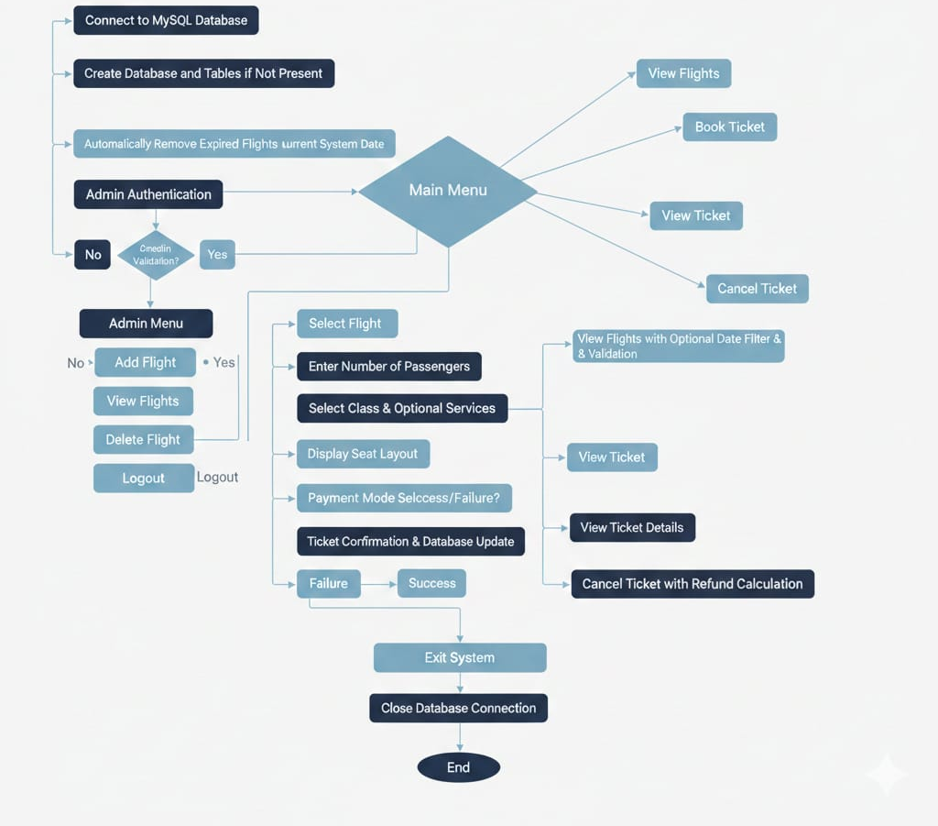

Resources:
https://github.com/manas-28-afk/Computer-Science-Project-C-12.git
Conclusion
The Airport Management System developed using Python and MySQL successfully demonstrates how database-driven applications can be used to manage real-world operations efficiently. The system provides secure admin control for managing flight records and a user-friendly interface for passengers to view flights, book tickets, select seats, and make payments. By integrating features such as date-wise filtering, automatic removal of expired flights, and proper validation mechanisms, the project ensures data accuracy and prevents invalid operations.
Overall, this project highlights the effective use of Python programming concepts, MySQL database management, and structured program design to create a reliable and realistic management system. It not only fulfills the functional requirements of an airport booking system but also enhances understanding of DBMS concepts, transaction control, and real-time data handling, making it a valuable learning experience.

Bibliography
- Visual Studio:
https://code.visualstudio.com/
- MySQL:
https://www.mysql.com/
- Spyder:
https://www.spyder-ide.org/
- Noto:
https://fonts.google.com/noto/specimen/Noto+Emoji
- Emojipedia:
https://emojipedia.org/
- Geeks4Geeks:
https://www.geeksforgeeks.org/python/

